An introduction to the public mural of the Polytechnic University of the Philippines

Mga Rebolusyonaryo

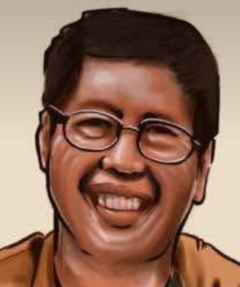 | 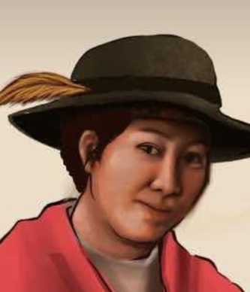 | 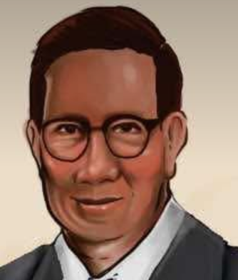
Leonard Co,  Bayani Ko! | Maria Y. Orosa:  Tagapaglitas! | Eduardo Quisimbing:  Muhon ng Bayan

The nation commemorates Filipinos who gave their lives to the country, often in contexts of armed conflict or state persecution. This mural remembers with profound admiration and affection the likes of Andres Bonifacio, Jose Rizal, Macario Sakay, Remedios "Kumander Liwayway" Gomez-Paraiso, Simeona “Kumander Guerrero” Punzalan, Lorena Barros, and Nemesio Prudente. But it also seeks to reimagine nationalism and redefine the word "rebolusyonaryo" and what qualifies as revolutionary in the nationalist pantheon.

By elevating the profile of three figures of science, we are sending a message to the youth today: revolutionaries are not only Filipinos who fought and many times helped bring down those who sought to enslave our people; they are also Filipinos dedicated to promoting science, to giving life, to protecting and enabling Philippine ecosystems—and thus the Philippines as nation as well—to endure and flourish. In the face of the climate crisis, which threatens our long-term viability as a nation, our people need to learn from and use everything in the toolbox.

On the left side of the painting, wearing a vest and his trademark smile, stands a giant in Philippine science, Leonardo Legaspi Co, “Leonard” to friends and family, the people’s botanist, a conservation biologist and ethnopharmacologist. He considered the forest his university and only received “a Bachelor of Science in Botany degree from the University of the Philippines-Diliman—three decades and a half after his first admission to the state university as a freshman” because the late scientist Perry Ong fought with the esteemed mathematician Fidel Nemenzo to get university officials to confer on Leonard academic recognition the botanist never chased. Leonard was the founder and first president of the Philippine Native Plants Conservation Society, Inc. or PNPCSI. Co’s influence on and contribution to the field of biology was immense. When scientists led by Julie Barcelona discovered a new species of the plant Rafflesia in 2008, they named it Rafflesia leonardii, after their mentor, Leonard Co. According to Barcelona, on 15 November 2010, while working in the field for a reforestation project of the Energy Development Corporation (EDC) in Kananga, Leyte, Leonard “met his untimely death at the hands of his supposed protectors, the Philippine Army. His death, together with forest guard Sofronio Cortez and farmer Julius Borromeo, in an alleged crossfire between the 19th Infantry Battalion team and the New Peoples' Army rebels, was a big loss to his country. While justice surrounding their deaths proves elusive, the country mourns for its most loved botanist.”

In the middle of the mural is the food scientist, Maria Y. Orosa, “Filipino food scientist, war hero, and humanitarian.” Orosa’s work “began in the 1920s all the way into the years of WWII when food and ingredients were scarce. Through her indefatigable resourcefulness, endless experimentations, substitutions, and researches, she came up with recipes using only what were available at the time.” A great lesson here many may have lost but which the mural might remind them to recover once again: In a land of abundance, facing dire perils from a climate crisis only beginning to unfold, we cannot, must not, take for granted what the land gives everyone. Orosa’s most famous invention is banana ketchup, the palayok oven, and “Magic Powder,” the powdered soybean (is now known as Soyalac) she smuggled to malnourished prisoners and their families during wartime. But her work spanned far more –soybeans, cassava, papaya, rice bran, coconut meal, and more culinary innovations. Orosa “earned three bachelor of science degrees in pharmaceutical chemistry, food chemistry, and pharmacy and a master of science degree in pharmacy at the University of Washington at Seattle.” Orosa “secretly held the rank of captain in the underground during the Second World War while still going to office daily at the government plant industry laboratory in San Andres, Manila.” Towards the end of the fascist rule under Japanese Occupation, when others had fled the besieged city, Orosa chose to stay in Manila. “My place is here,” said Orosa, “I cannot in conscience abandon my work...” In 1945 Orosa was mortally wounded during a bombing raid in Malate. She was buried in a mass grave.

From the other side is a stately gentleman. He is Eduardo Quisimbing, esteemed scientist and “author of over 129 scientific articles, many on orchids,” including the epically massive book, Medicinal Plants of the Philippines, and the Teratology of Philippine Orchids, The identity of Anota Violacea and Rhynchostylis Retus, New or Noteworthy Philippine Orchids, Philippine Orchids, and Philippine Piperceae. Quisimbing was a botanist, an orchidologist, and a noted expert on Philippine medicinal plants. His publications and papers are still sold on sites such as Amazon. And his writings on orchids of the Philippines are still available at college libraries throughout the U.S. His contributions to orchidology has been so significant an orchid was named after him, the Saccolabium quisumbingii. Quisimbing was born on 24 November 1895 in Sta Cruz, Laguna. He earned his BSA in biology (1918) and his Master of Science in botany (1921) from the University of the Philippines Los Baños. His PhD he earned at the University of Chicago (in Plant Taxonomy, Systematics and Morphology) in 1923. Quisimbing was attached to the College of Agriculture at the University of the Philippines, and from 1926 to 1928 at the University of California. Quisimbing received the Distinguished Service Star for outstanding contribution to the field of systematic botany (1954), the Diploma of Merit on Orchidology and Fellow Gold Medal from the Malaysian Orchid Society (1966), the American Orchid Society’s Gold Medal (1969), and the 1975 PhilAAS Most Outstanding Award. Quisimbing became the acting chief of the Natural Museum Division of the Bureau of Science in Manila and later, as the Director of the country’s National Museum, Quisimbing led the restoration of the country’s Herbarium, which was completely destroyed under Japanese occupation during the anti-fascist world war. Quisimbing died in Quezon City on 23 August 1986.

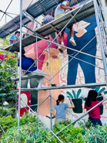 | Click here to learn more about the artists and the notes and observations from all the collaborators: aesthetic notes, individual insights, challenges, and expectations, and all the interesting behind-the-scenes accounts from participating artists.

https://www.philippineplants.org/General/AboutLeonard.html
https://repository.naturalis.nl/pub/525759/BLUM2008053001002.pdf
Ibid. 1
The words accompanied a Google Doodle in honor of Orosa on the occasion of her 126th birth anniversary, from “Maria Y. Orosa: The Idea of Public Service,” by R.C. Ladrido, 21 January 2021, Verafiles.org. See https://verafiles.org/articles/maria-y-orosa-idea-public-service
The rest of the paragraph is sourced from Appetite for Freedom, The Recipes of Maria Y. Orosa, with Essays on Her Life and Work (Ige Ramos Design Studio, Manila: 2021). The book also features over 700 recipes and kitchen techniques for home cooks. It won the National Book Award for Best Design during the 40th National Book Awards.
https://www.thoughtco.com/eduardo-quisumbing-botanist-1991733
https://www.thoughtco.com/eduardo-quisumbing-botanist-1991733
https://members.nast.ph/index.php/list-of-national-scientist/details/3/29

